Neptune4
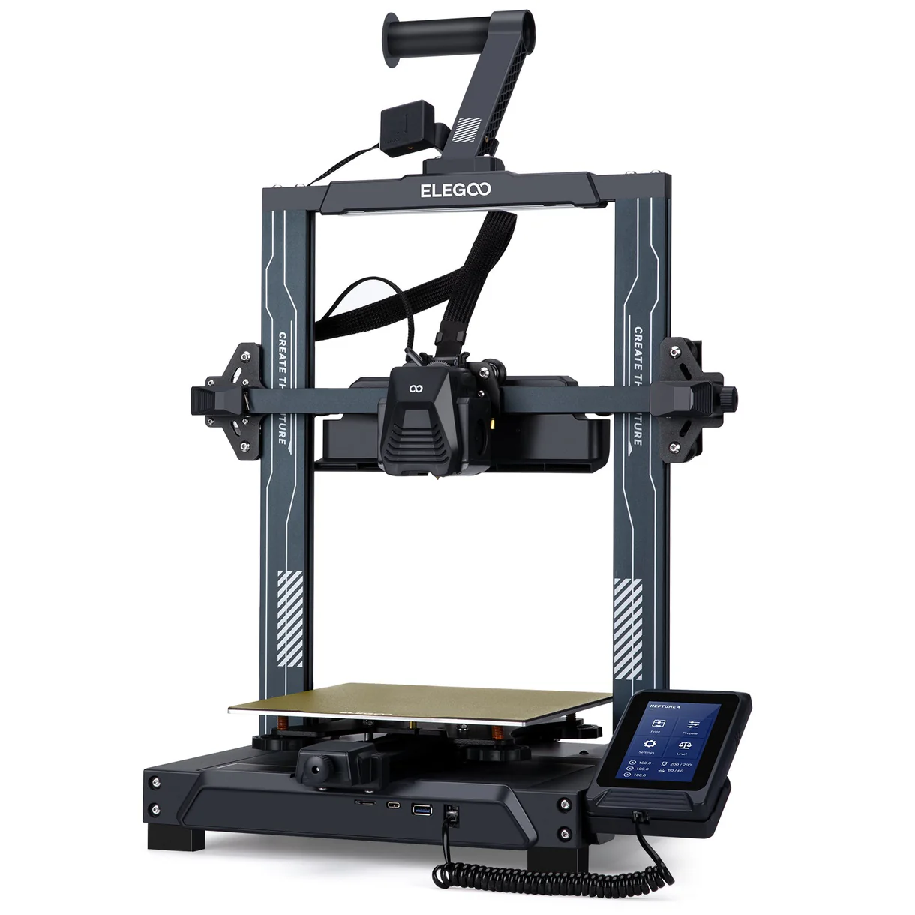

LED修正メモ
1.Add these to your printers home/mks folder. Open Putty and run bash install.sh (Its normal if it returns an oooopsie,just move on) Remove lines in printer.cfg about flashlight and replace with these: [gcode_shell_command hotend] command: sh /home/mks/toggleled.sh timeout: 30. verbose: True
[gcode_shell_command overhead] command: sh /home/mks/toggleovr.sh timeout: 30. verbose: True
[gcode_macro Hotend LED] description: Turn on Hotend LEDs gcode:
RUN_SHELL_COMMAND CMD=hotend
[gcode_macro Overhead LED] description: Turn on Hotend LEDs gcode:
RUN_SHELL_COMMAND CMD=overhead
4: Profit

